Wegener Family Photographs
Notes: Scanned from original unless otherwise noted. CHI = Concordia Historical Institute, St. Louis, Missouri

 | WPHO | IDENTIFICATION | DATE | SIZE | SOURCE | SCANNED AT | NOTES
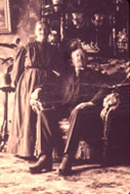 | 0001 | Gottfried J. B. Wegener & Lisette (Hadeler) Wegener. | ca 1906 | Unknown | Alice F. Wegener  (Location of original now unknown.) | 1600 ppi  (from 35mm slide) | Copies (slides and negs) from original by Norman Hellmers.  To CHI
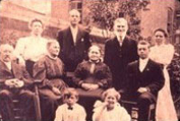 | 0002 | Gottfried J. B. Wegener & Lisette (Hadeler) Wegener and relatives. | ca 1906-1908, based on ages of youngest children | Unknown | Alice F. Wegener  (Location of original now unknown.) | 1200 ppi  (from 35mm slide) | Copies (slides and negs) from original by Norman Hellmers.  To CHI
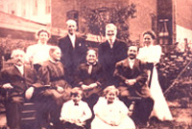 | 0003 | Gottfried J. B. Wegener & Lisette (Hadeler) Wegener and relatives. | ca 1906-1908, based on ages of youngest children | Unknown | Alice F. Wegener  (Location of original now unknown.) | 1200 ppi  (from 35mm slide) | Copies (slides and negs) from original by Norman Hellmers.  To CHI
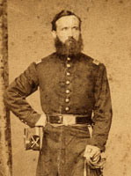 | 0004 | Julius von Wittke in Civil War uniform. | ca 1861-1863 | 2.5 x 4.5 | Kevin Bozant | 600 ppi | To CHI
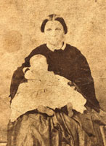 | 0005 | Juliane (Tullius) von Wittke and daughter, Juliane von Wittke. | ca late 1863 | 2.5 x 3.5 (trimmed) | Kevin Bozant | 600 ppi | Taken at studio of Philipp Rupp in NYC. (See back of CDV.)  To CHI
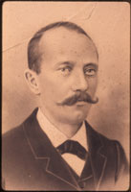 | 0006 | John F. Klein. | Unknown; late 1800s | 13.5 x 17 | Meta Wegener Hellmers | 1600 ppi  (from 35mm slide) | Original to  Historic New Orleans Collection  Copies to CHI
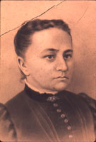 | 0007 | Christine (Haerer) Klein. | Unknown; late 1800s | 13.5 x 17 | Meta Wegener Hellmers | 1600 ppi  (from 35mm slide) | Original to  Historic New Orleans Collection  Copies to CHI
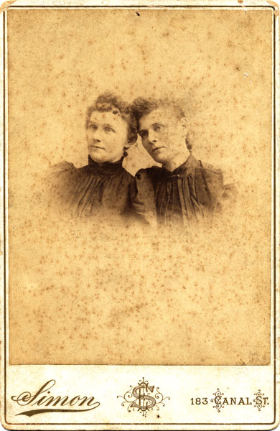 | 0008 | Auguste and Juliane von Wittke (sisters). | ca 1887-1895 | 4.25 x 6.5 | Kevin Bozant | 600 ppi | These were the only two children of Julius and Juliane (Tullius) vonWittke.  To CHI
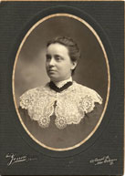 | 0009 | Anna Klein. | ca 1905 | 5 x 7 | Wegener Family | 600 ppi | Three originals.  To CHI
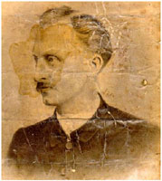 | 0010 | G. J. Wegener. | ca 1882 | 8 x 10 | Kevin Bozant (from Carl Wegener) | 400 ppi | Earliest known image of G. J. Wegener, perhaps from time of seminary graduation or ordination. To CHI
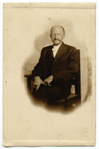 | 0011 | G. J. Wegener. | Unknown | 3.5 x 5.5 | Wegener Family | 600 ppi | Postcard format. Taken at Bachelor’s, Cincinnati, Ohio.  Two originals.  To CHI
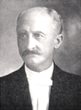 | 0012 | G. J. Wegener.  In his autobiography, GJW said he was 50 when this photo was taken. | ca 1911 | Unknown | No original found | 600 ppi | Copied from The Lutheran Church in Louisiana, by John Nau.
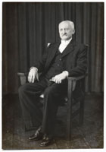 | 0013 | G. J. Wegener.  Presumably taken for the 100th anniversary of St. Paul Lutheran Church, New Orleans, La. | 1940 | 4.5 x 6.5 | Wegener Family | 600 ppi | Taken at Pon’s Studio, 3901 St. Claude Ave., New Orleans, La.  To CHI
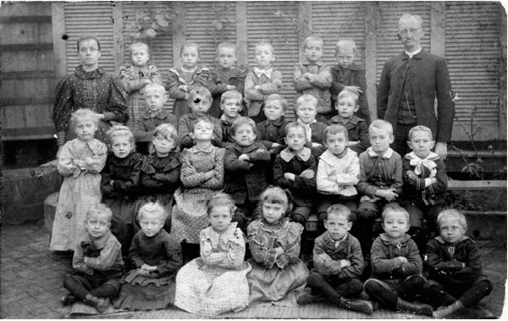 | 0014 | St. Paul School Class, includes G. J. Wegener and Anna Klein | 1895 | 7 x 4.5 | St. Paul Lutheran Church Archives, donated by Carl Wegener | 96 ppi | Original in archives of St. Paul Lutheran Church, New Orleans.  Copy to CHI
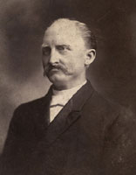 | 0015 | G. J. Wegener. | ca 1907 | 4.25 x 6.5 | Wegener Family | 300 ppi | Two originals. Used for the Silver Jubilee of G. J. Wegener’s ordination.  To CHI
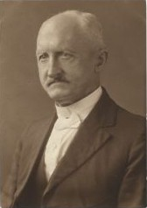 | 0016 | G. J. Wegener.  Used for printed message to “my catechumens” in 1927 and in 90th anniversary publication of St. Paul Lutheran Church. | ca 1927 | 3 x 4.4 | Wegener Family | 600 ppi | To CHI
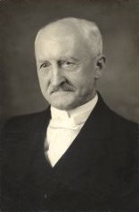 | 0017 | G. J. Wegener.  In his autobiography, GJW said he was 80 when this photo was taken. Used for the 100th anniversary of St. Paul Lutheran Church, New Orleans. | ca 1940 | 3.75 x 5.8 | Wegener Family | 600 ppi | Two copies and negative.  To CHI
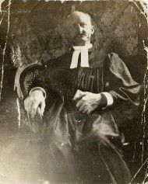 | 0018 | G. J. Wegener. | Unknown | 2.4 x 2.9 | Wegener Family | 600 ppi | To CHI
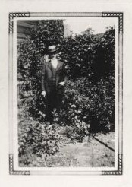 | 0019 | G. J. Wegener. | 1940 | Unknown | Wegener Family | 600 ppi | Print made from original by Kevin Bozant; location of original now unknown.  To CHI
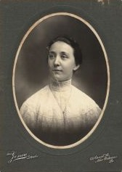 | 0020 | Maria Elisabethe "Mary" Klein. | ca 1905 | 5 x 7 | Wegener Family | 600 ppi | G. J. Wegener’s unmarried sister-in-law.  To CHI
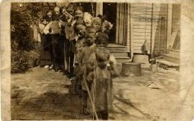 | 0021 | Wegener family.  Written on back: “The big family.” | ca 1915 | 5.5 x 3.5 | Wegener Family | 600 ppi | Postcard format.  To CHI
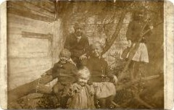 | 0022 | Wegener children after 1915 storm.  Marked on back: “Some survivors of the storm.” [New Orleans was struck by a hurricane in September 1915.] | 1915 | 5.5 x 3.5 | Wegener Family | 600 ppi | Postcard format.  To CHI
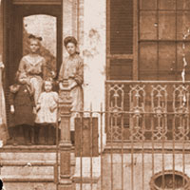 | 0023 | Wegener children at the parsonage of St. Paul Lutheran Church, New Orleans, Louisiana. Back, left to right: Lydia, Julia. Front, left to right: Gertrude, Olga. | ca 1903 | 5 x 3.8  on a 7 x 7 backing | Wegener Family | 600 ppi | To CHI
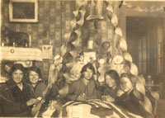 | 0024 | Wegener daughters with friends in parsonage parlor. | ca 1914-1916, based on the ages of the girls | 5.5 x 3.5 | Wegener Family | 600 ppi | Postcard format  To CHI
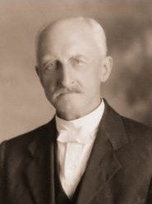 | 0025 | G. J. Wegener  About the time of their 25th wedding anniversary. | ca 1930 | 4 x 6 | Frieda Wegener Speckhard | 600 ppi | Taken at Pon’s Studio, 4131 Burgundy Street, New Orleans.  To CHI
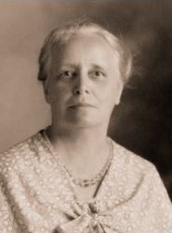 | 0026 | Anna (Klein) Wegener  About the time of their 25th wedding anniversary. | ca 1930 | 4 x 6 | Frieda Wegener Speckhard | 600 ppi | Taken at Pon’s Studio, 4131 Burgundy Street, New Orleans.  To CHI
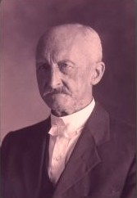 | 0027 | G. J. Wegener  About the time of their 40th wedding anniversary. | 1945 | Unknown | The whereabouts of the original are currently unknown. | 1600 ppi  (from 35mm slide) | Scan of color slide made from an original.  To CHI
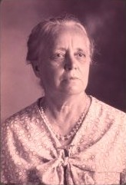 | 0028 | Anna (Klein) Wegener  About the time of their 40th wedding anniversary. | 1945 | Unknown | The whereabouts of the original are currently unknown. | 1600 ppi  (from 35mm slide) | Scan of color slide made from an original.  To CHI
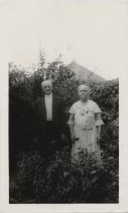 | 0029 | G. J. Wegener and Anna Klein Wegener. | 1934 | 3.5 x 5.8 | Wegener Family | 600 ppi | To CHI
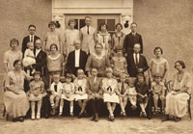 | 0030 | G. J. Wegener and family in courtyard of St. Paul Lutheran Church and School, New Orleans. | 1923 | 10 x 8 | Meta Wegener Hellmers | 600 ppi | To CHI
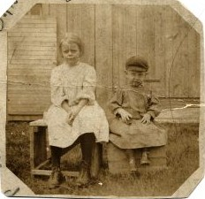 | 0031 | Olga Wegener and William “Willie” Essig in Michigan. (G. J. Wegener and wife—and at least Olga— were in Michigan for the baptism of Willie’s younger brother, Edmund.) | Jul 1908 | 2.75 x 2.75 | Wegener Family | 600 ppi | Cut to smaller size from a postcard mailed from Michigan.  To CHI
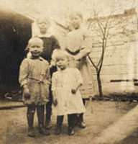 | 0032 | Wegener family (Back, left to right: Olga, Gertrude; front row: Carl, Anna). | ca 1908-1909 | 3.5 x 3.5 | Wegener Album | 600 ppi | Album to CHI
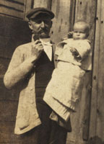 | 0033 | G. J. Wegener and unidentified child. | Unknown | 2.25 x 3.25 | Wegener Album | 600 ppi | Album to CHI
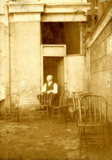 | 0034 | G. J. Wegener in church yard by door of coal bin. | Unknown | 3.25 x 4.25 | Wegener Family | 600 ppi | Trimmed copy in Wegener Album.  To CHI
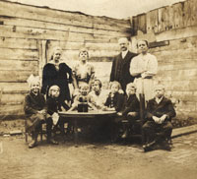 | 0035 | G. J. Wegener and family. | ca 1915 | 3.5 x 3.25 | Wegener Album | 600 ppi | Album to CHI
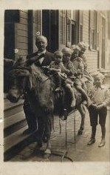 | 0036 | G. J. Wegener and children on donkey. | ca 1912 | 3.4 x 5.4 | Meta Wegener Hellmers, copy also in Wegener Album | 600 ppi | Postcard format  Three complete originals; one trimmed original.  To CHI
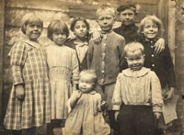 | 0037 | Wegener children (oldest six Wegener-Klein children) and two unidentified friends. | ca 1914 | 4.25 x 3.5 | Wegener Album | 600 ppi | Presumably originally in postcard format.  Album to CHI
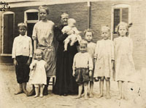 | 0038 | Wegener children (oldest seven Wegener-Klein children) and Olga and Mrs. Elizabeth Kaufmann Dinkgreve. | 1915 | 4.75 x 3.5 | Wegener Album | 600 ppi | Originally in postcard format. One postcard not in album.  To CHI
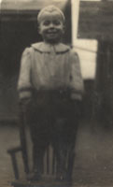 | 0039 | Walther Wegener. | ca 1915 | 3.5 x 4.75 | Wegener Album | 600 ppi | Originally in postcard format.  Album to CHI
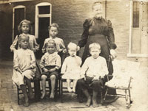 | 0040 | Wegener children (oldest seven Wegener-Klein children) and Mrs. Elizabeth Kaufmann Dinkgreve. | 1915 | 4.75 x 3.5 | Wegener Album | 600 ppi | Originally in postcard format.  Album to CHI
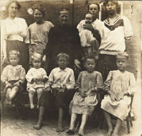 | 0041 | Wegener children (oldest seven Wegener-Klein children), others, and Mrs. Elizabeth Kaufmann Dinkgreve. | 1915 | 4.75 x 3.5 | Wegener Album | 600 ppi | Originally in postcard format.  Album to CHI
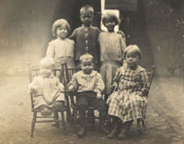 | 0042 | Wegener children (oldest six Wegener-Klein children). | ca 1915 | 4.75 x 3.5 | Wegener Album | 600 ppi | Originally in postcard format.  One postcard not in album.  To CHI
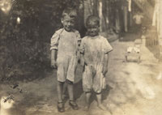 | 0043 | Walther Wegener and Edmund Wegener. | ca 1915 | 4.75 x 3.5 | Wegener Album | 660 ppi | Originally in postcard format.  Album to CHI
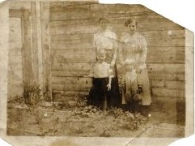 | 0044 | Wegener children and friend: Augusta [?], “Bess Walde” [sp], Walther, Louise [?]. | ca 1915 | 5 x 3.75 | Wegener Family | 600 ppi | To CHI
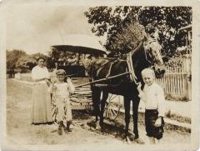 | 0045 | Carl Wegener with horse and wagon; others unidentified. | ca 1915 | 4.1 x 3.2 | Wegener Family | 600 ppi | To CHI
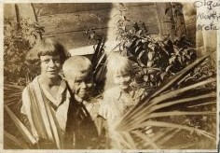 | 0046 | Wegener children: Olga, Martin, Meta. | ca 1922 | 3.1 x 2.2 | Keim Family | 600 ppi | Taken in backyard behind parsonage.  To CHI
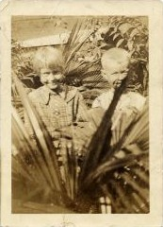 | 0047 | Wegener children: Meta, Martin. | ca 1922 | 2.5 x 3.5 | Keim Family | 600 ppi | Taken in backyard behind parsonage.  To CHI
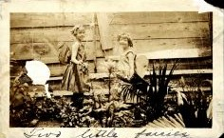 | 0048 | Meta Wegener and Helen Kliemand [?]. | ca 1923 | 4.5 x 2.75 | Cut from an unknown album. | 600 ppi | Taken in backyard behind parsonage.  To CHI
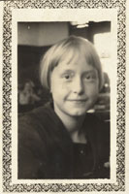 | 0049 | Meta Wegener. | ca 1925 | 1.75 x 2.6 | Wegener Album | 600 ppi | School photo.  Album to CHI
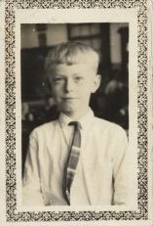 | 0050 | Martin Wegener. | Unknown | 1.75 x 2.6 | Wegener Album | 600 ppi | School photo.  Album to CHI
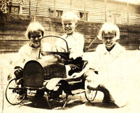 | 0051 | Louise, Martin, and Meta Wegener. | ca 1922 | 3.6 x 2.5 | Wegener Album | 600 ppi | Album to CHI
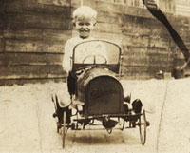 | 0052 | Martin Wegener. | ca 1922 | 3.6 x 2.5 | Wegener Album | 600 ppi | Album to CHI
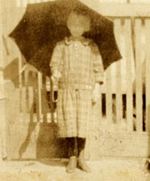 | 0053 | Louise Wegener. | ca 1922-23 | 2.8 x 4.5 | Wegener Album | 600 ppi | Album to CHI
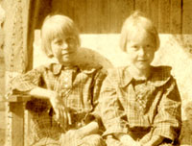 | 0054 | Louise and Meta Wegener. | ca 1922-23 | 4.5 x 2.8 | Wegener Album | 600 ppi | Album to CHI
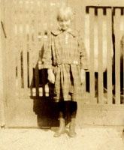 | 0055 | Meta Wegener. | ca 1922-23 | 2.8 x 4.5 | Wegener Album | 600 ppi | Album to CHI
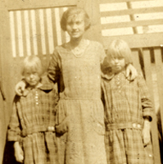 | 0056 | Meta and Louise Wegener with Clara Meyn. | ca 1922-23 | 4.5 x 2.75 | Wegener Album | 600 ppi | Album to CHI
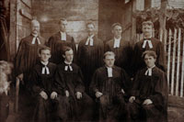 | 0057 | Rev. Otto Wismar Ordination and Installation at Mount Calvary Lutheran Church, New Orleans, La. | 28 Aug 1910 | 5.5 x 4 on an 8 x 6 mat | Wegener Family | 600 ppi | To CHI
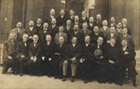 | 0058 | [Presumably a] Lutheran Convention, G. J. Wegener in attendance.  Message from GJW to one of his sons on the reverse. | Unknown | 5.4 x 3.4 | Wegener Family | 600 ppi | Postcard format.  To CHI
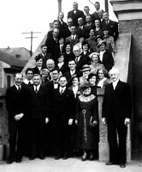 | 0059 | Walther League Junior Counselors Conference, St. Paul. New Orleans. | 7 Feb 1937 | 5 x 7 | Wegener Family | 600 ppi | To CHI
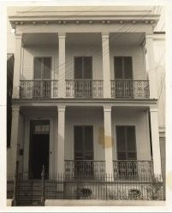 | 0060 | Parsonage, 824 Port Street, of St. Paul Lutheran Church and home of the family of G. J. Wegener from 1887 to 1946. | 1 Dec 1943 | 8 x 10 | Wegener Family | 400 ppi | Taken by H. C. Hartmann for autobiography. Signed by Wegener on back.  To CHI
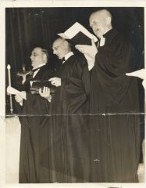 | 0061 | Revs. Herbert B. Roepe, Theodore H. A. Wegener, G. J. Wegener; 100th anniversary service at Municipal Auditorium, New Orleans, La. | 21 Apr 1940 | 7 x 9 | Frieda Wegener Speckhard to Kevin Bozant | 400 ppi | To CHI
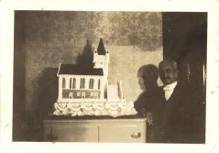 | 0062 | G. J. Wegener at Golden Jubilee of his installation at St. Paul Lutheran Church with cake. | 24 Oct 1937 | 3.5 x 2.5 | Louise Wegener Randolph | 600 ppi | Two copies.  To CHI
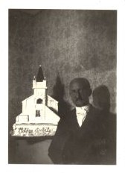 | 0063 | G. J. Wegener at Golden Jubilee of his installation at St. Paul Lutheran Church with cake. | 24 Oct 1937 | 2.5 x 3.5 | Louise Wegener Randolph | 600 ppi | To CHI
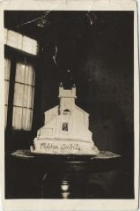 | 0064 | Cake for Golden Jubilee of G. J. Wegener’s installation at St. Paul Lutheran Church. | 24 Oct 1937 | 2.5 x 3.5 | Louise Wegener Randolph | 600 ppi | To CHI
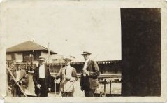 | 0065 | G. J. Wegener [second from left] and other men fishing, probably at Lake Pontchartrain. | July 1921 | 5.75 x 3.5 | Elwood Keim | 600 ppi | A second view taken at the same time is identified as wpho0065a.  To CHI
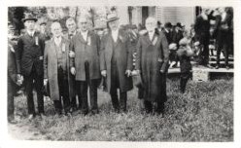 | 0066 | G. J. Wegener at event. | Unknown | Unknown | Elwood Keim | 300 ppi | Original scanned by Kevin Bozant. Status of original unknown.  To CHI
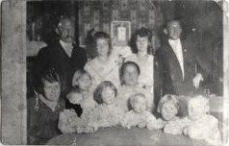 | 0067 | G. J Wegener family in parsonage parlor. | ca 1914 | Unknown | Elwood Keim | 300 ppi | Original scanned by Kevin Bozant. Status of original unknown.  To CHI
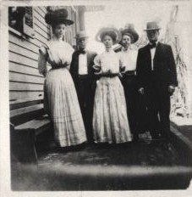 | 0068 | Wegener girls outside parsonage; unidentified. | Unknown | Unknown | Elwood Keim | 300 ppi | Original scanned by Kevin Bozant. Status of original unknown.  To CHI
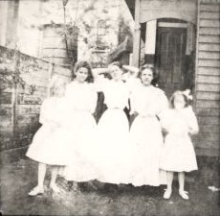 | 0069 | Wegener girls and other girls; unidentified. | Unknown | Unknown | Elwood Keim | 300 ppi | Original scanned by Kevin Bozant. Status of original unknown.  To CHI
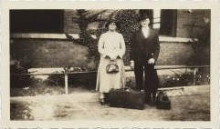 | 0070 | G. J. Wegener and Anna Wegener at train station in Kewanee, Illinois. | 1933 | 4.5 x 2.75 | Wegener Family | 600 ppi | To CHI
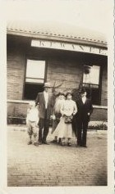 | 0071 | G. J. Wegener and Anna Wegener in Kewanee, Illinois, with Adolph Felten and son and an unidentified woman. | 1933 | 2.75 x 4.5 | Wegener Family | 600 ppi | To CHI
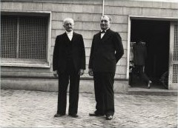 | 0072 | G. J. Wegener and Rev. Herbert Roepe. | 1940 | 5 x 7 | Wegener Family | 600 ppi | Taken at the time of the 100th anniversary of St. Paul Lutheran Church, New Orleans.  To CHI
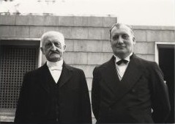 | 0073 | G. J. Wegener and Rev. Herbert Roepe. | 1940 | 7 x 5 | Wegener Family | 600 ppi | Taken at the time of the 100th anniversary of St. Paul Lutheran Church, New Orleans.  To CHI
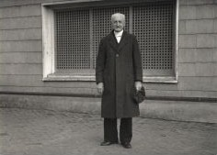 | 0074 | G. J. Wegener. | 1940 | 5 x 7 | Wegener Family | 600 ppi | Taken at the time of the 100th anniversary of St. Paul Lutheran Church, New Orleans.  To CHI
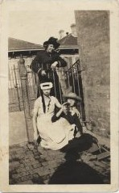 | 0075 | Wegener girls: Gertrude [top], Olga [lower right], and an unidentified girl. | ca 1915-1920 | 2.75 x 4.5 | Wegener Family | 600 ppi | Taken at the front of St. Paul Lutheran Church, New Orleans.  To CHI
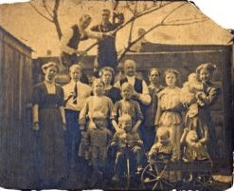 | 0076 | G. J. Wegener family. | ca 1910-1911 | Unknown | Abigail Dunlop Bottome | 300 ppi | No original or copy available, only a scan.
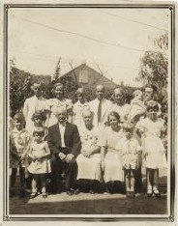 | 0077 | G. J. Wegener family (Olga and family and Gertrude and family). | 1934 | 3.5 x 4.5 | Wegener Family | 600 ppi | The photographer cut off someone on the left; perhaps, Meta, who is missing. Two copies.  To CHI
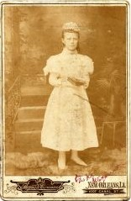 | 0078 | Juliane “Julia” C. A. Wegener, confirmation. | April 1897 | 4.25 x 6.25 | Wegener Family | 600 ppi | Taken at Rojas & Conner Photographers, 1007 Canal St., New Orleans, LA.  To CHI
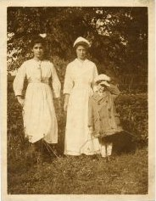 | 0079 | Juliane “Julia” C. A. Wegener in nurse’s uniform. | Unknown | 3.25 x 4.25 | Wegener Family | 600 ppi | Two children in photo are unidentified.  To CHI
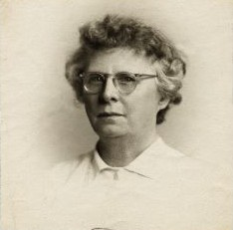 | 0080 | Juliane “Julia” C. A. Wegener. | Unknown | 2.5 x 2.5 | Wegener Family | 600 ppi | To CHI
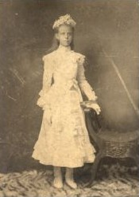 | 0081 | Lydia H. L. Wegener, confirmation. | ca April 1901 | Unknown | Abigail Dunlop Bottome | 72 ppi | No original or copy available, only a scan.
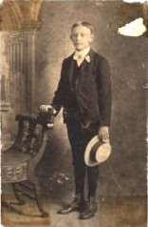 | 0082 | Theodore A. H. Wegener, confirmation. | 1905 | Unknown | Theo Wegener Family | 600 ppi | Status of original unknown.
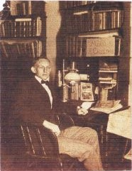 | 0083 | Theodore Wegener at Concordia Seminary. | ca 1911-1914 | 3.9 x 4.9 | Marie Wegener Roberts | 600 ppi | Scanned from a low quality print. Status of original unknown.  To CHI
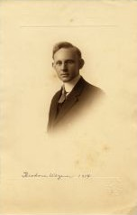 | 0084 | Rev. Theodore A. H. Wegener  (perhaps at the time of his graduation from the Seminary). | 1914 | 7 x 11 | Wegener Family | 600 ppi | Taken at Oldfield [Studios], 3518 N. Grand Ave., St. Louis.  To CHI
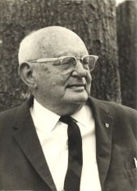 | 0085 | Rev. Theodore A. H. Wegener. | 18 Jun 1966 | 5 x 7 | Wegener Family | 600 ppi | Two similar photos.  To CHI
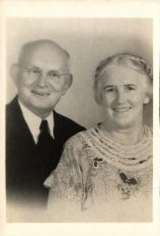 | 0086 | Theodore A. H. and Adeline M. Amerland Wegener. | 1956 | 2.4 x 3.4 | Wegener Family | 600 ppi | Presumably taken for their 40th wedding anniversary.  Two copies.  To CHI
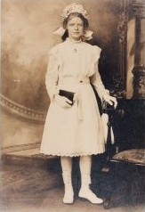 | 0087 | Olga C. E. Wegener, confirmation. | 1913 | 4 x 6 (copy) | Kevin Bozant | 600 ppi | Scanned from a 4x6 color print. Status of original unknown.  To CHI
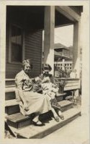 | 0088 | Gertrude W. Gabriel (left) holding her son Herbert H. Gabriel (born 7 February 1925) and Olga W. Keim holding her daughter, Marian G. Keim (born 1 December 1925). | Jan 1926 | 2.8 x 4.75 | Wegener Family | 600 ppi | To CHI
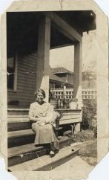 | 0089 | Gertrude Wegener and Marian Keim in Hammond, Louisiana. Back says: “Gert & Marian age 6 weeks in Hammond.” | Jan 1926 | 3 x 4.75 | Wegener Family | 600 ppi | To CHI
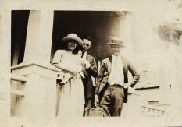 | 0090 | Gertrude Wegener Gabriel, Henry Gabriel, Carl Wegener. Child presumably: Leonard E. Gabriel, born 15 Jun 1923. Back says: “August, 1923.” | Aug 1923 | 3.5 x 2.5 | Wegener Family | 600 ppi | To CHI
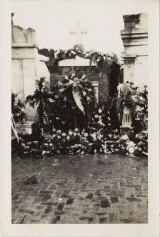 | 0091 | Wegener Tomb at the time of G. J. Wegener’s death. | Nov 1946 | 3.5 x 5 | Wegener Family | 600 ppi | Two similar views.  To CHI
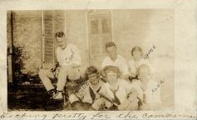 | 0092 | Wegener children and others, includes: Carl, Frieda, Olga, Anna. Also, teacher Elmer Groth. Unidentified young woman. | ca 1924-1925 | 4.5 x 2.75 | Wegener Family | 600 ppi | To CHI
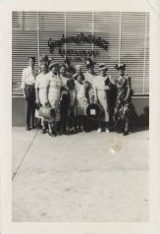 | 0093 | Wegener family group, including Julia and Lydia. | ca 1947 | 3.5 x 5 | Wegener Family | 600 ppi | To CHI
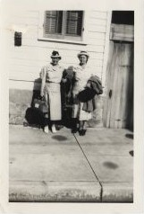 | 0094 | Julia and Lydia Wegener. Back says: “leaving Port St for NY.” | ca 1947  [same day as 0093] | 3.5 x 5 | Wegener Family | 600 ppi | To CHI
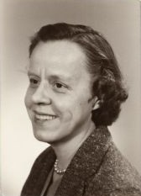 | 0095 | Hulda Wegener, teacher, school photograph. | Unknown | 3.5 x 5 | Bozant Family | 600 ppi | To CHI
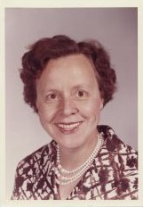 | 0096 | Hulda Wegener, teacher, school photograph. Taken at McDonogh 39 School, New Orleans, La. | Apr 1963 | 3.5 x 5 | Bozant Family | 600 ppi | To CHI
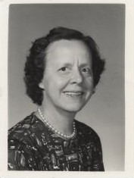 | 0097 | Hulda Wegener, teacher, school photograph. Taken at McDonogh 39 School, New Orleans, La. | 9 Nov 1964 | 2 x 2.6 | Bozant Family | 600 ppi | To CHI
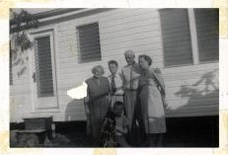 | 0098 | Wegener sisters: Gertrude and husband Henry Gabriel; Augusta and husband Adolph Felten. David Randolph in foreground. Taken at Randolph home. | ca 1955 | 5 x 3.5 | Randolph Family | 600 ppi | To CHI
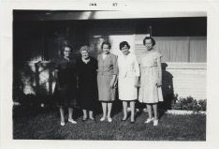 | 0099 | Wegener sisters: Louise, Gertrude, Hulda, Meta, Hulda. | ca 1966-1967  [photo dated January 1967] | 5 x 3.5 | Randolph Family | 600 ppi | To CHI
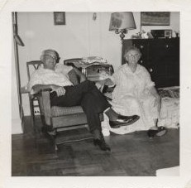 | 0100 | Theodore Wegener and Julia Wegener. | Aug 1960 | 3.5 x 3.5 | Theodore Wegener | 600 ppi | To CHI
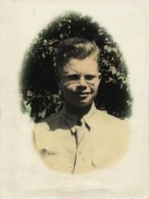 | 0101 | Herbert H. Gabriel  born 7 Feb 1925; killed in France while serving with the U. S. Army, 17 Jul 1944. | ca 1943-1944 | 4.3 x 5.9 | Wegener Family | 600 ppi | To CHI
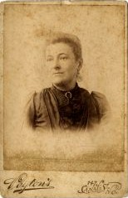 | 0102 | Unidentified woman  Taken at Peyton’s, 147 Canal St., N. O. | ca 1890s  (before 1895) | 4.25 x 6.5 | Wegener Family | 600 ppi | To CHI
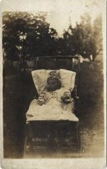 | 0103 | Unidentified child. | Unknown | 3.4 x 5.5 | Wegener Family | 600 ppi | Postcard format.  To CHI
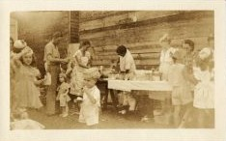 | 0104 | Unidentified group. | Sep 1945  Date on back | 4.6 x 2.9 | Wegener family | 600 ppi | To CHI
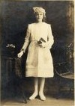 | 0105 | Anna M. J. Wegener, confirmation. | ca April 1920 | 6 x 9 | Wegener Family | 600 ppi | Taken at Barnes Foto Studio, 3329 Dauphine St., New Orleans.  To CHI
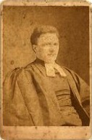 | 0106 | The Rev. Edmund Bohm, Director  St. Matthew Academy, Manhattan, NY. | ca 1880s | 4.25 x 6.5 | In G. J. Wegener Papers | 600ppi | Taken at Hagelstein Bros., Photographers, 142 Bowery, New York  To CHI
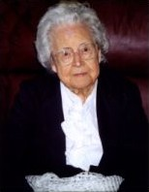 | 0107 | Frieda Wegener Speckhard. | ca 2000 | Not recorded | Speckhard-Wegener family | 150 ppi | To CHI
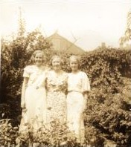 | 0108 | Anna and Louise Wegener with a third woman. | 1934  [same day as 0029 and 0077] | 3.75 x 4.75 | Removed from an unknown album | 600 ppi | To CHI
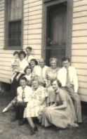 | 0109 | Keim, Gabriel, Walther Wegener families. | 1949 | Unknown | Scan from Kevin Bozant; status of original unknown | 200 ppi
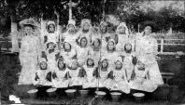 | 0110 | 1903 Picnic Milk Pail group. | ca 1903 | Not recorded | Archives, St. Paul Lutheran Church | 96 ppi
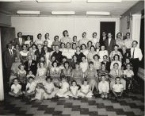 | 0111 | 1960 Wegener Reunion, entire group. | 2 Jul 1960 | 10 x 8 | Hellmers-Wegener family | 300 ppi | To CHI
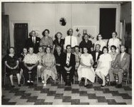 | 0112 | 1960 Wegener Reunion; children and spouses. | 2 Jul 1960 | 10 x 8 | Hellmers-Wegener family | 300 ppi | To CHI
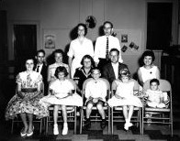 | 0113 | 1960 Keim Family at Reunion. | 2 Jul 1960 | 10 x 8 | Kevin Bozant | 200 ppi
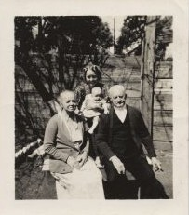 | 0114 | G. J. Wegener and Anna Klein Wegener with Meta and Leonard H. Hellmers Jr. | 1940 | 2.4 x 2.8 | Hellmers-Wegener family | 600 ppi
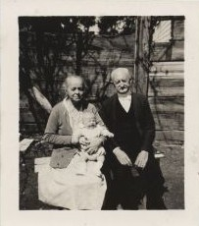 | 0115 | G. J. Wegener and Anna Klein Wegener with Leonard H. Hellmers Jr. | 1940 | 2.4 x 2.8 | Hellmers-Wegener family | 600 ppi
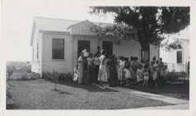 | 0116 | Wegener Reunion. | 1950 | 4.5 x 2.75 | Hellmers-Wegener family | 600 ppi | To CHI
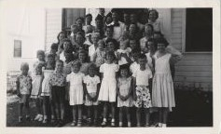 | 0117 | Wegener Reunion. | 1950 | 4.5 x 2.75 | Hellmers-Wegener family | 600 ppi | To CHI
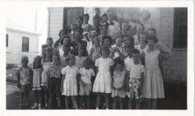 | 0118 | Wegener Reunion. | 1950 | 4.5 x 2.75 | Hellmers-Wegener family | 600 ppi | To CHI
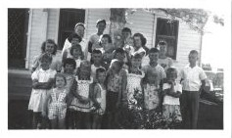 | 0119 | Wegener Reunion. | 1950 | 4.5 x 2.75 | Hellmers-Wegener family | 600 ppi | To CHI
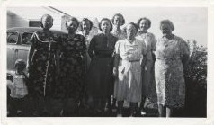 | 0120 | Wegener Reunion. | 1950 | 4.5 x 2.75 | Hellmers-Wegener family | 600 ppi | To CHI
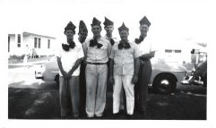 | 0121 | Wegener Reunion. | 1950 | 4.5 x 2.75 | Hellmers-Wegener family | 600 ppi | To CHI
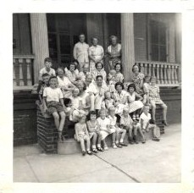 | 0122 | Wegener Reunion.  Written on back: “Merry Christmas and a Happy New Year, Lydia & Dutz, 1950.” | 1950 | 3.5 x 3.5 | Hellmers-Wegener family | 600 ppi | To CHI
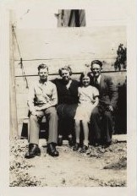 | 0123 | Gabriel Family: Henry Gabriel, Gertrude Wegener Gabriel, Herbert (in military uniform), Arlene. | 1943-44 | 3.5 x 5 | Hellmers-Wegener family | 600 ppi | To CHI
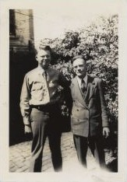 | 0124 | Gabriel Family: Henry Gabriel and Herbert (in military uniform). | 1943-44 | 3.5 x 5 | Hellmers-Wegener family | 600 ppi | To CHI
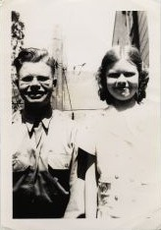 | 0125 | Gabriel Family: Herbert (in military uniform) and Arlene. | 1943-44 | 3.5 x 5 | Hellmers-Wegener family | 600 ppi | To CHI
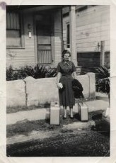 | 0126 | Gabriel Family: Arlene Gabriel  Written on back: “Taken on Sept 8th 1951. Just before leaving for Nurses Training in Lutheran Hospital of St. Louis, Mo.” | Sep 8, 1951 | 3.5 x 5 | Hellmers-Wegener family | 600 ppi | To CHI
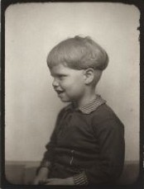 | 0127 | Gabriel Family: Herbert. | ca 1927-1930 | 1.5 x 2 | Hellmers-Wegener family | 600 ppi | To CHI
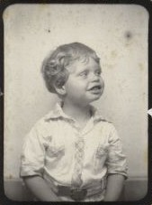 | 0128 | Gabriel Family: Herbert. | ca 1927-1930 | 1.5 x 2 | Hellmers-Wegener family | 600 ppi | To CHI
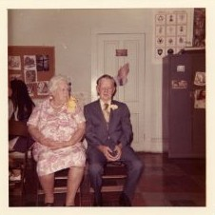 | 0129 | Gabriel Family: Henry and Gertrude Wegener Gabriel, 50th wedding anniversary. | June 1972 | 3.5 x 3.5 | Hellmers-Wegener family | 600 ppi | To CHI
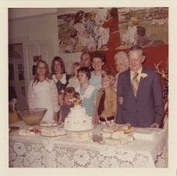 | 0130 | Gabriel Family: Henry and Gertrude Wegener Gabriel, 50th wedding anniversary. Kretzmann family: Otto, Arlene, Deborah, Elizabeth, Sarah, Nathan, Rebecca, Rachel, Anna. | June 1972 | 3.5 x 3.5 | Hellmers-Wegener family | 600 ppi | To CHI
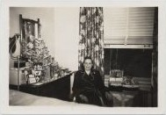 | 0131 | Anna Wegener at the Lutheran Sanitarium in Wheat Ridge, Colorado. | 5 Jan 1948 | 3.5 x 2.5 | Hellmers-Wegener family | 600 ppi | To CHI
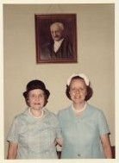 | 0132 | Anna and Hulda Wegener. | Unknown | 5 x 7 | Hellmers-Wegener family | 300 ppi | To CHI
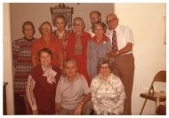 | 0133 | Wegener siblings and spouses. | bet. 1978-1984 | 7 x 5 | Hellmers-Wegener family | 300 ppi | To CHI
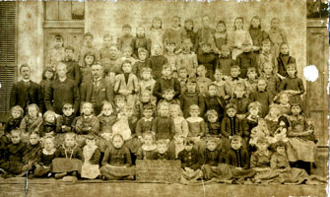 | 0134 | School class, St. Paul Lutheran. | 8 March 1892 | Not recorded | Archives, St. Paul Lutheran Church | 200 ppi
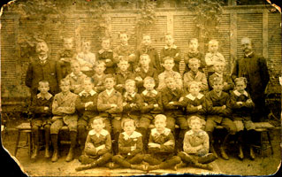 | 0135 | School class, St. Paul Lutheran. | 19 Nov 1895 | Not recorded | Archives, St. Paul Lutheran Church | 200 ppi
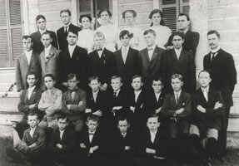 | 0136 | Class at Concordia College, New Orleans. | ca 1908 | Unknown | Hellmers Family | 300 ppi | Black and white copy made from an original, the status of which is unknown.  To CHI
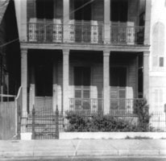 | 0137 | Parsonage of St. Paul Lutheran Church and home of the family of G. J. Wegener from 1887 to 1946. | 1941 | Not recorded | Wegener-Oppermann family | 400 ppi
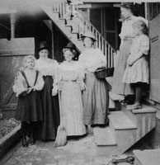 | 0138 | Wegener daughters and other girls outside parsonage. | 1910 | Not recorded | Wegener-Oppermann family | 400 ppi
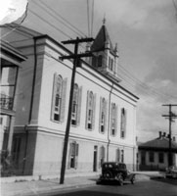 | 0139 | St. Paul Lutheran Church; parsonage at far left. | 1941 | Not recorded | Wegener-Oppermann family | 400 ppi
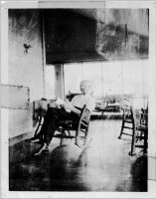 | 0140 | G J Wegener “Papa taken on porch of Krause’s summer house at Big Lake.” |  | Not recorded | Wegener-Oppermann family | 400 ppi
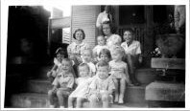 | 0141 | Wegener grandchildren. | 1944 | Not recorded | Wegener-Oppermann family | 400 ppi
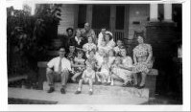 | 0142 | Wegener family group. | 1944 | Not recorded | Wegener-Oppermann family | 400 ppi
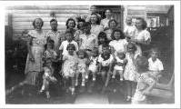 | 0143 | Wegener family group. | 1944 | Not recorded | Wegener-Oppermann family | 400 ppi
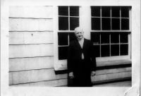 | 0144 | G. J. Wegener. | April 1943 | Not recorded | Wegener-Oppermann family | 400 ppi
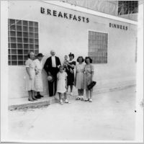 | 0145 | Wegener family group. | 1941 | Not recorded | Wegener-Oppermann family | 400 ppi
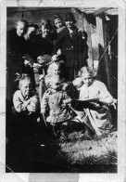 | 0146 | Wegener family group. | ca 1919 | Not recorded | Wegener-Oppermann family | 400 ppi
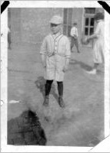 | 0147 | Martin Wegener in baseball uniform. | Unknown | Not recorded | Wegener-Oppermann family | 400 ppi
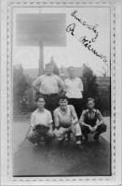 | 0148 | Martin Wegener in basketball uniform. | Unknown | Not recorded | Wegener-Oppermann family | 400 ppi
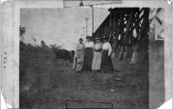 | 0149 | Wegener daughters and others. | 1920 | Not recorded | Wegener-Oppermann family | 400 ppi
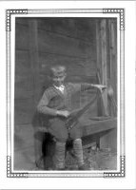 | 0150 | Martin Wegener playing saw. | Unknown | Not recorded | Wegener-Oppermann family | 400 ppi
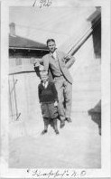 | 0151 | Martin Wegener with teacher Elmer Groth. | 1926 | Not recorded | Wegener-Oppermann family | 400 ppi
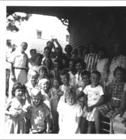 | 0152 | Wegener family group. | Summer 1950 | Not recorded | Wegener-Oppermann family | 400 ppi
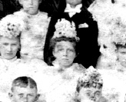 | 0153 | Julia Wegener confirmation. | 16 May 1897 | Not recorded | Archives, St. Paul Lutheran Church | 96 ppi
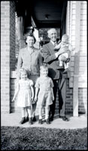 | 0154 | Adolph and Augusta Wegener Felten (Adolph holding Norman Hellmers). | 1945 | 2.75 x 4.5 | Hellmers-Wegener family | 600 ppi
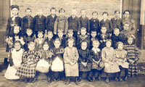 | 0155 | St. Paul Lutheran School class (includes Anna Klein). | 1903 | Not recorded | Archives, St. Paul Lutheran Church | 100 ppi
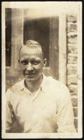 | 0156 | Carl Wegener. | ca 1930 | 3.25 x 5.5 | Wegener album | 600 ppi | Album to CHI
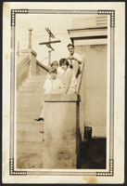 | 0157 | Frieda Wegener and Herman Speckhard with Anna and Hulda Wegener. | ca 1930-1931 | 3.25 x 4.75 | Wegener album | 600 ppi | Album to CHI
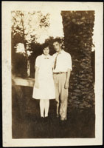 | 0158 | Frieda Wegener and Herman Speckhard. | ca 1930-1931 | 2.5 x 3.6 | Wegener album | 600 ppi | Album to CHI
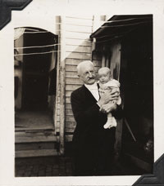 | 0159 | G. J. Wegener and Leonard H. Hellmers, Jr. | 1940 | 2.4 x 2.8 | Hellmers-Wegener family | 300 ppi
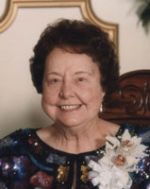 | 0160 | Meta Wegener Hellmers on her 80th birthday. | 23 Dec 1994 | Not recorded | Hellmers-Wegener family | 600 ppi
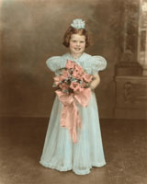 | 0161 | Arlene Gabriel as flower girl in wedding of Leonard Hellmers and Meta Wegener. | July 1938 | 7.75 x 9.75 | Hellmers-Wegener family | 300 ppi | To CHI
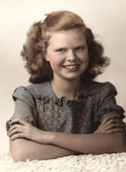 | 0162 | Arlene Gabriel, perhaps high school graduation. | ca 1951 | 5 x 7 | Hellmers-Wegener family | 400 ppi | To CHI
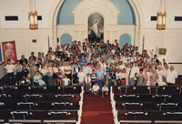 | 0163 | 1990 Wegener reunion, entire group in St. Paul Lutheran Church. | August 5, 1990 | 12 x 8 | Hellmers-Wegener family | 300 ppi | To CHI
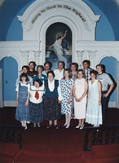 | 0164 | 1990 Wegener reunion, Hellmers-Wegener family. | August 5, 1990 | 5 x 7 | Hellmers-Wegener family | 400 ppi | To CHI
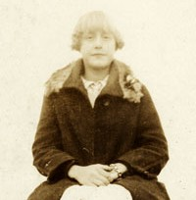 | 0165 | Meta Wegener, sitting on capstan at lock on Industrial Canal. | ca 1927-1929 | 2.8 x 4.6 | Wegener Album | 600 ppi | Album to CHI
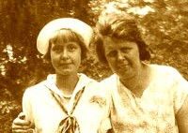 | 0166 | Meta Wegener and Gertrude Wegener with two boys (one is Herbert Gabriel). | ca 1928-1930 | 3 x 4.8 | Wegener Album | 600 ppi | Album to CHI
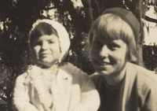 | 0167 | Louise Wegener and unidentified girl. | ca 1929-1931 | 2.75 x 4.5 | Wegener Album | 600 ppi | Album to CHI
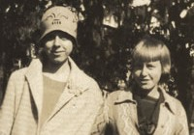 | 0168 | Hulda Wegener and Meta Wegener. | ca 1929-1931 | 2.75 x 4.5 | Wegener Album | 600 ppi | Album to CHI
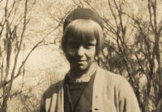 | 0169 | Louise Wegener. | ca 1929-1931 | 2.75 x 4.5 | Wegener Album | 600 ppi | Album to CHI
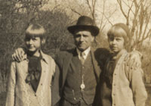 | 0170 | Meta Wegener, unidentified man, Louise Wegener. | ca 1929-1931 | 2.75 x 4.5 | Wegener Album | 600 ppi | Album to CHI
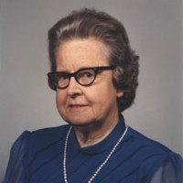 | 0171 | Frieda Wegener. The occasion for the photograph, if any, is not known. | 1985 | 2.4 x 3.4 |  | 600 ppi | To CHI
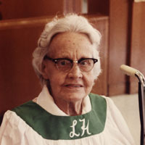 | 0172 | Anna Wegener. Taken about the time of Anna's 81st birthday, which was May 23, 1988, at Lutheran Home in New Orleans. | 1988 | 3.5 x 5 |  | 600 ppi | To CHI
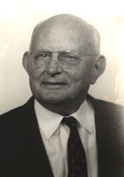 | 0173 | Theodore A. H. “Theo” Wegener. | Undated | 3.5 x 5 |  | 600 ppi | To CHI
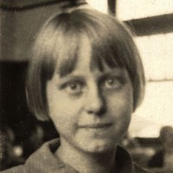 | 0174 | Louise D. A Wegener (1913-1997).  Notes: Taken at St. Paul Lutheran School, New Orleans. | ca 1925 | 1.75 x 2.6 |  | 600 ppi | To CHI
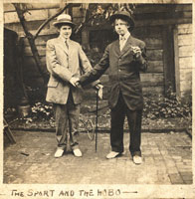 | 0175 | The “Hobo” (right) is Theo Wegener. The “Sport” is unidentified. Cut from a postcard mailed from St. Louis, 27 Sep 1912. | 1912 | 3.75 x 3.5 |  | 600 ppi | Postcard format (trimmed).  To CHI
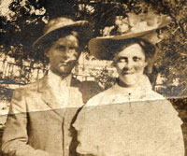 | 0176 | Unidentified couple. Cut from an album. | Undated | 3.5 x 3.25 |  | 600 ppi | To CHI
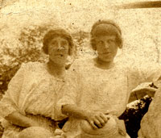 | 0177 | Unidentified women. Left, may be Adeline Amerland. Right, may be Gertrude Wegener. Adeline married Theo Wegener in 1916; Gertrude married Henry Gabriel in 1922. | Undated | 3.25 x 3.5 |  | 600 ppi | Postcard format (trimmed).  To CHI
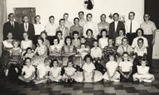 | 0178 | Wegener grandchildren and great-grandchildren at Wegener reunion. | 2 July 1960. | 10 x 8 | Hellmers-Wegener Family | 300 ppi | To CHI
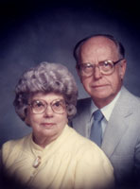 | 0179 | Elizabeth "Beth" H. Oppermann Wegener and Martin A. Wegener. Martin and Beth were married in 1941. | ca 1991 | 2.5 x 2.75 |  | 600 ppi | To CHI
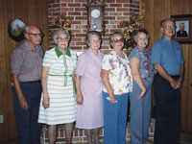 | 0180 | The surviving children of G. J. Wegener. Carl Wegener, Anna Wegener, Frieda Wegener Speckhard, Louise Wegener Randolph, Meta Wegener Hellmers, Martin Wegener. | ca 1985-1988 | 5.25 x 3.5 |  | 600 ppi | To CHI
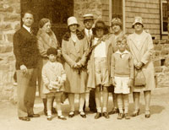 | 0181 | Edmund Wegener family with others. | ca 1930 | 5.75 x 3.5 | Wegener Album | 600 ppi | Album to CHI
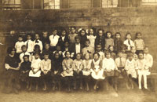 | 0182 | School class (younger half) at St. Paul Lutheran School, New Orleans. Carl Wegener, back row, fourth from left. Anna Wegener, front row, seventh from left (with bow in hair). | 1913-1914 | 7 x 4.75  mat, 8.5 x 6.5 | Carl Wegener | 600 ppi | To CHI
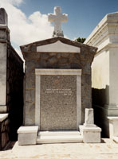 | 0183 | Wegener Tomb in St. Vincent de Paul Cemetery, New Orleans, LA. | June 1993 | 4 x 6 | Martin Wegener | 600 ppi | To CHI
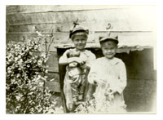 | 0184 | Louise Wegener (age 4) and Meta Wegener (age 2), probably outside of parsonage. | ca 1917 | Unknown  Copy 7 x 5 | Hellmers-Wegener Family  Location of original unknown. | 600 ppi | To CHI
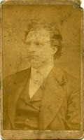 | 0185 | Unidentified man. May have been associated with St. Matthew Academy in NYC. (See wpho0106.) | Unknown | 2.5 x 4 | In G. J. Wegener Papers |  | To CHI
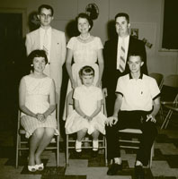 | 0186 | 1960 Wegener Family Reunion,  Hellmers-Wegener family. | 2 Jul 1960 | 10 x 8 | Hellmers-Wegener Family
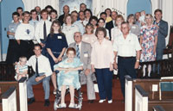 | 0187 | 1990 Wegener Family Reunion,  Wismar-Wegener family. | 5 Aug 1990 | 6 x 4 | Hellmers-Wegener Family | 600 ppi | To CHI
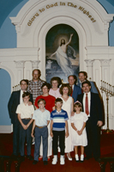 | 0188 | 1990 Wegener Family Reunion, Keim-Wegener family. | 5 Aug 1990 | 4 x 6 | Hellmers-Wegener Family | 600 ppi | To CHI
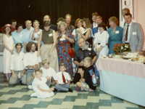 | 0189 | 1990 Wegener Family Reunion,  Wegener-Henneberg family. | 5 Aug 1990 | 6 x 4 | Hellmers-Wegener Family | 600 ppi | To CHI
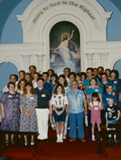 | 0190 | 1990 Wegener Family Reunion,  Randolph-Wegener family. | 5 Aug 1990 | 4 x 6 | Hellmers-Wegener Family | 600 ppi | To CHI
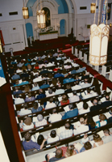 | 0191 | 1990 Wegener Family Reunion,  devotion in sanctuary of St. Paul Lutheran Church, New Orleans, LA. | 5 Aug 1990 | 4 x 6 | Hellmers-Wegener Family | 600 ppi | To CHI
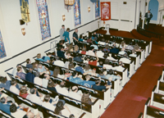 | 0192 | 1990 Wegener Family Reunion,  devotion in sanctuary of St. Paul Lutheran Church, New Orleans, LA, led by the Rev. Otto H. Kretzmann. | 5 Aug 1990 | 6 x 4 | Hellmers-Wegener Family | 600 ppi | To CHI
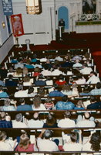 | 0193 | 1990 Wegener Family Reunion,  devotion in sanctuary of St. Paul Lutheran Church, New Orleans, LA, led by the Rev. Otto H. Kretzmann. | 5 Aug 1990 | 4 x 6 | Hellmers-Wegener Family | 600 ppi | To CHI
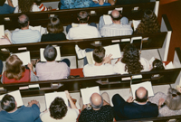 | 0194 | 1990 Wegener Family Reunion,  devotion in sanctuary of St. Paul Lutheran Church, New Orleans, LA. | 5 Aug 1990 | 6 x 4 | Hellmers-Wegener Family | 600 ppi | To CHI
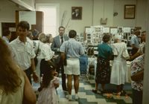 | 0195 | 1990 Wegener Family Reunion,  reception in basement of St. Paul Lutheran Church, New Orleans, LA. | 5 Aug 1990 | 6 x 4 | Hellmers-Wegener Family | 600 ppi | To CHI
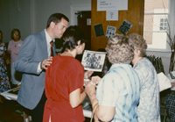 | 0196 | 1990 Wegener Family Reunion,  reception in basement of St. Paul Lutheran Church, New Orleans, LA. | 5 Aug 1990 | 6 x 4 | Hellmers-Wegener Family | 600 ppi | To CHI
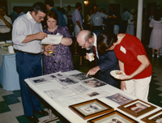 | 0197 | 1990 Wegener Family Reunion,  reception in basement of St. Paul Lutheran Church, New Orleans, LA. | 5 Aug 1990 | 6 x 4 | Hellmers-Wegener Family | 600 ppi | To CHI
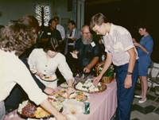 | 0198 | 1990 Wegener Family Reunion,  reception in basement of St. Paul Lutheran Church, New Orleans, LA. | 5 Aug 1990 | 6 x 4 | Hellmers-Wegener Family | 600 ppi | To CHI
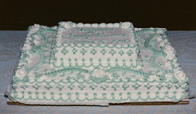 | 0199 | 1990 Wegener Family Reunion,  reception in basement of St. Paul Lutheran Church, New Orleans, LA. | 5 Aug 1990 | 6 x 4 | Hellmers-Wegener Family | 600 ppi | To CHI
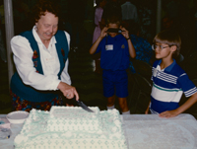 | 0200 | 1990 Wegener Family Reunion,  reception in basement of St. Paul Lutheran Church, New Orleans, LA. | 5 Aug 1990 | 6 x 4 | Hellmers-Wegener Family | 600 ppi | To CHI
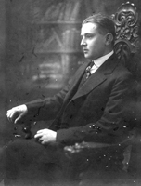 | 0201 | Frederick Kurt Kliemand (1889-1947), husband of Lydia Wegener. | Unknown | 5 x 7  4 x 6 copy | Dunlop-Kliemand Family | 300 ppi | To CHI
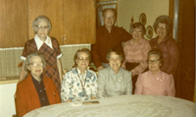 | 0202 | Wegener children (Hulda, Anna, Louise, Meta, Martin) and in-laws (Helen Henneberg Wegener and Elizabeth Oppermann Wegener). | ca Mar 1983 | 4 x 3.5 | Hellmers-Wegener Family | 600 ppi | To CHI
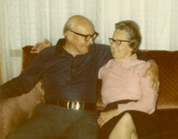 | 0203 | Carl Wegener and Frieda Wegener Speckhard. | ca Mar 1983 | 4 x 3.5 | Hellmers-Wegener Family | 600 ppi | To CHI
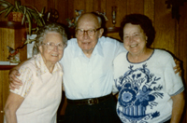 | 0204 | Frieda Wegener Speckhard, Carl Wegener, Meta Wegener Hellmers. | ca Sep 1991 | 4 x 3.5 | Hellmers-Wegener Family | 600 ppi | To CHI
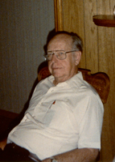 | 0205 | Martin Wegener. | ca Sep 1991 | 3.5 x 4 | Hellmers-Wegener Family | 600 ppi | To CHI
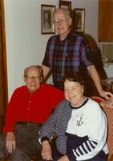 | 0206 | Carl Wegener, Martin Wegener, Meta Wegener Hellmers. | ca Feb 1993 | 3.5 x 5 | Hellmers-Wegener Family | 600 ppi | To CHI
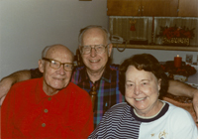 | 0207 | Carl Wegener, Martin Wegener, Meta Wegener Hellmers. | ca Feb 1993 | 5 x 3.5 | Hellmers-Wegener Family | 600 ppi | To CHI
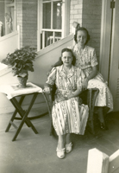 | 0208 | Anna and Hulda Wegener  (taken when Anna Wegener was at the Lutheran Sanitarium in Wheat Ridge, Colorado. (See wpho0131.) | ca 1947-1948 | 2.75 x 4.5 | Hellmers-Wegener Family | 600 ppi | To CHI
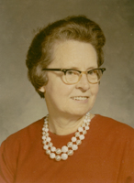 | 0209 | Frieda Wegener Speckhard as a school teacher. | Jan 1972 | 1.75 x 2.5 | Hellmers-Wegener Family | 600 ppi | To CHI
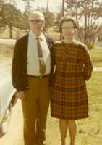 | 0210 | Herman and Frieda Wegener Speckhard. | Jun 1971 | 3.5 x 3.5 | Hellmers-Wegener Family | 600 ppi | To CHI
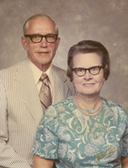 | 0211 | Herman and Frieda Wegener Speckhard. | 1975 | 2.5 x 3.1 | Hellmers-Wegener Family | 600 ppi | To CHI
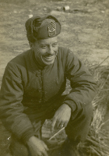 | 0212 | Walther Wegener in the U. S. Army (21st Infantry Regiment, 24th Infantry Division) in Taegu, Korea. | 1951 | 3.5 x 5.75 | Hellmers-Wegener Family | 600 ppi | To CHI
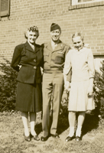 | 0213 | Mary Wegener, Walther Wegener, Mary Elaine Wegener “along side our apartment windows.” |  | 2.75 x 4.5 | Hellmers-Wegener Family | 600 ppi | To CHI
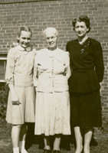 | 0214 | Mary Elaine Wegener, Mary Wegener’s mother, and “a friend of Mary’s from Georgia” (Cynthia Marsh). |  | 2.75 x 4.5 | Hellmers-Wegener Family | 600 ppi | To CHI
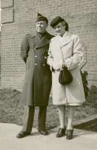 | 0215 | Walther Wegener and Mary Wegener. |  | 3.25 x 3.25 | Hellmers-Wegener Family | 600 ppi | To CHI
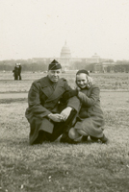 | 0216 | Walther Wegener and his daughter Mary Elaine Wegener. |  | 3.25 x 3.25 | Hellmers-Wegener Family | 600 ppi | To CHI
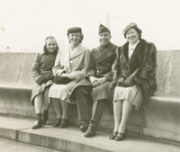 | 0217 | Mary Elaine Wegener, Mary Wegener, Walther Wegener, unidentified woman. |  | 3.25 x 3.25 | Hellmers-Wegener Family | 600 ppi | To CHI
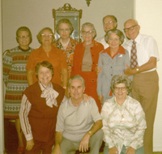 | 0218 | Wegener children and spouses: (back) Frieda, Louise, Hulda, Anna, Martin, Helen Henneberg Wegener, Carl; (front) Meta, Leonard Hellmers, Elizabeth Oppermann Wegener. | 1978 | 3.4 x 3.5 | Hellmers-Wegener Family | 600 ppi | To CHI
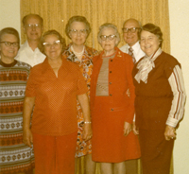 | 0219 | Wegener children: Frieda, Martin, Louise, Hulda, Anna, Carl, Meta. | 1978 | 3.4 x 3.5 | Hellmers-Wegener Family | 600 ppi | To CHI

