W-CTP-0002

KINGS COUNTY SURROGATE'S COURT.
New York Times (1857-Current file); May 24, 1874;
ProQuest Historical Newspapers, The New York Times, pg. 12

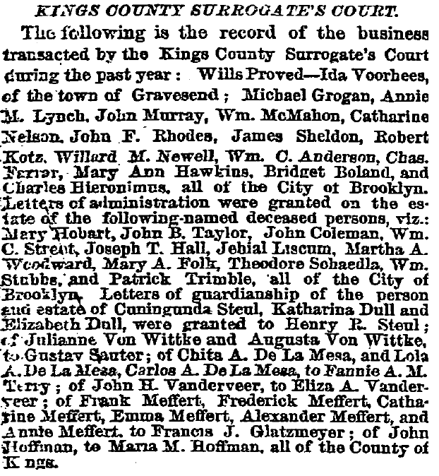

Downloaded from ProQuest.com on October 29, 2003.

