W-OBT-0072

New York Times (1857-Current file); Apr 21, 1918;
ProQuest Historical Newspapers The New York Times, pg. 21

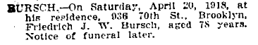

New York Times (1857-Current file); Apr 22, 1918;
ProQuest Historical Newspapers The New York Times, pg. 11

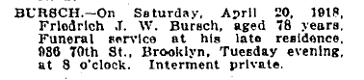

Downloaded from ProQuest.com on October 29, 2003.

