W-OBT-0074

Brooklyn Daily Eagle
Tuesday, July 7, 1896
page 16, column 4

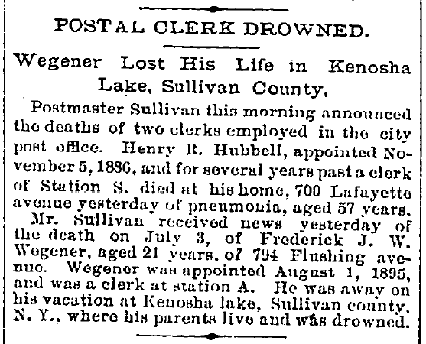

Downloaded from Brooklyn Daily Eagle online on November 6, 2006
http://www.brooklynpubliclibrary.org/eagle/

Note: Frederick Wegener’s parents lived in Brooklyn, and not in Sullivan County.

